附件：乌苏市历史遗留废弃矿山基本情况表
序号 | 图斑编号 | 图斑小类 | 地理位置 | 图斑面积（m²） | 中心坐标 |  | 拐点坐标 | 图斑影像
 |  |  |  |  | 经度 | 纬度
1 | CT6542022017000003001 | 无法确认治理恢复责任主体的无主废弃矿山 | 乌苏市西城区街道 | 205520 | 84.68753052 | 44.38564682 | 1,84.68557,44.38739  2,84.68466,44.38438  3,84.68498,44.38146  4,84.68669,44.38248  5,84.68752,44.38535  6,84.68815,44.38501  7,84.68746,44.38531  8,84.68879,44.38290  9,84.68980,44.38389  10,84.68970,44.38594  11,84.69110,44.38758  12,84.69092,44.38864 | 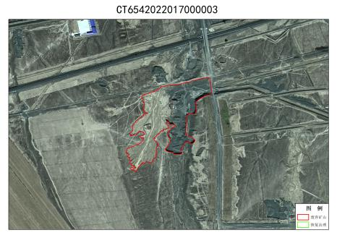
2 | CT6542022017000005002 | 无法确认治理恢复责任主体的无主废弃矿山 | 乌苏市古尔图镇 | 65523 | 83.88452911 | 44.45507431 | 1,83.68112,44.45641  2,83.88098,44.45528  3,83.88738,44.45395  4,83.88775,44.45503 | 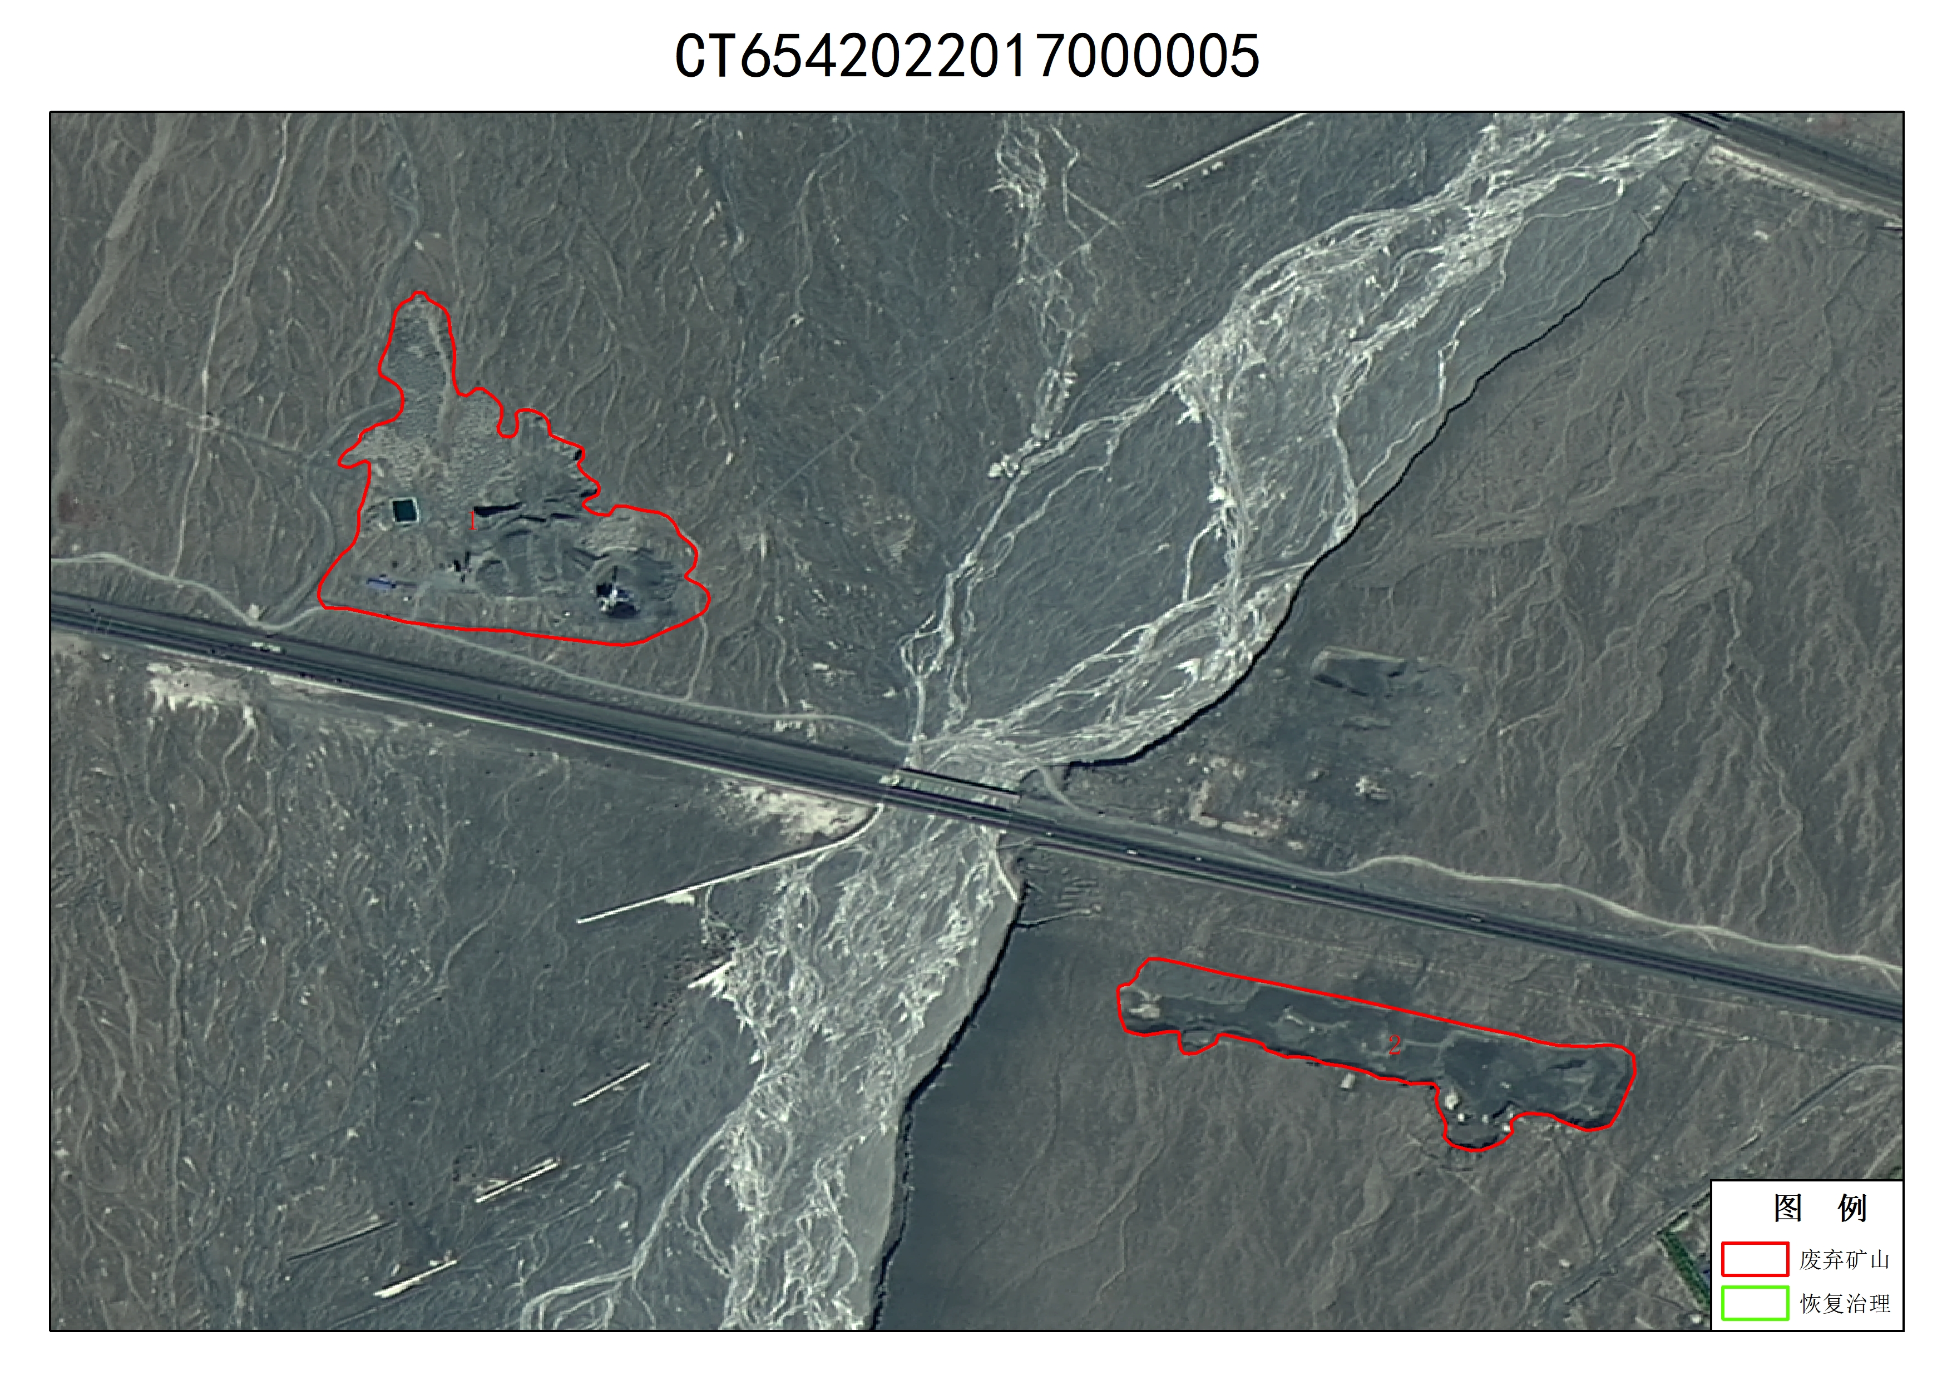
3 | CT6542022017000009001 | 无法确认治理恢复责任主体的无主废弃矿山 | 乌苏市百泉镇 | 56909 | 84.32737732 | 44.36506271 | 1,84.32551,44.36442  2,84.32598,44.38583  3,84.32913,44.36578  4,84.32869,44.36392 | 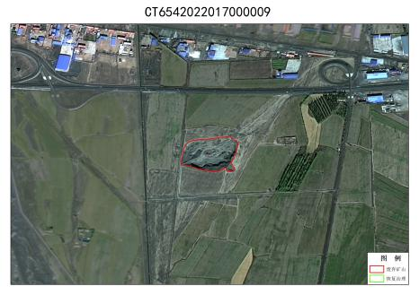
4 | CT6542022017000011001 | 无法确认治理恢复责任主体的无主废弃矿山 | 乌苏市白杨沟镇 | 270014 | 84.94582367 | 44.04321289 | 1,84.93831,44.04264  2,84.94917,44.04526  3,84.95055,44.04174  4,84.93996,44.04099 | 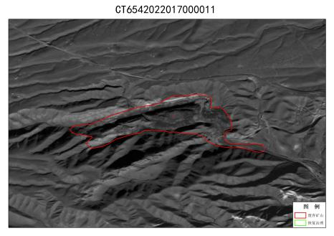
5 | CT6542022017000006001 | 无法确认治理恢复责任主体的无主废弃矿山 | 乌苏市古尔图镇 | 6607 | 83.88419342 | 44.46021652 | 1,83.88367,44.46053  2,83.88404,44.45026  3,83.88454,44.45980  4,83.88348,44.45014 | 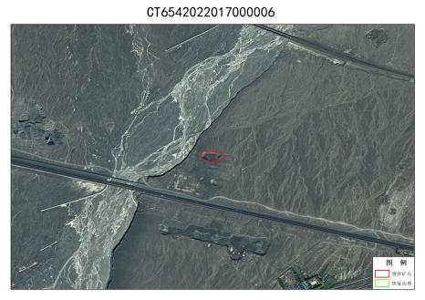
6 | ZJ6542022021007001 | 无法确认治理恢复责任主体的无主废弃矿山 | 乌苏市西大沟镇 | 57490 | 84.62215424 | 44.38351822 | 1,84.61977,44.38409  2,84.62430,44.38432  3,84.62473,44.38288  4,84.61987,44.38269 | 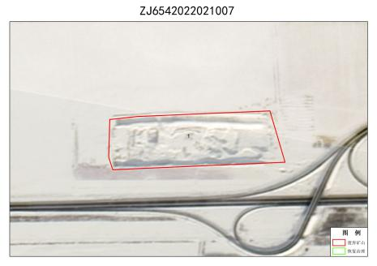
7 | ZJ6542022021010001 | 无法确认治理恢复责任主体的无主废弃矿山 | 乌苏市古尔图镇 | 72604 | 84.58960724 | 44.38342285 | 1,84.58662,44.38500  2,84.58809,44.38469  3,84.58845,44.38375  4,84.59334,44.38387  5,84.59336,44.38287  6,84.56727,44.38239 | 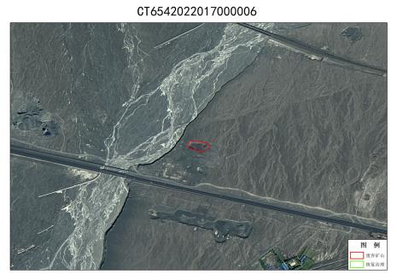
8 | CT6542022017000005001 | 无法确认治理恢复责任主体的无主废弃矿山 | 乌苏市古尔图镇 | 115943 | 83.87233734 | 44.46232986 | 1,83,87127,44.46534  2,83.87523,44.46123  3,83,86997,44.46110  4,83.87022,44.46309
9 | ZJ6542022021029001 | 无法确认治理恢复责任主体的无主废弃矿山 | 乌苏市百泉镇 | 21737 | 84.38931274 | 44.37640762 | 1,84.38666,44.37590  2,84.38974,44.37768  3,84.39124,44.37604  4,84.38746,44.37508 | 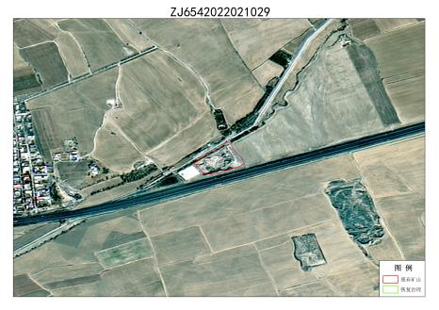
10 | ZJ6542022021028001 | 无法确认治理恢复责任主体的无主废弃矿山 | 乌苏市甘河子镇 | 28274 | 84.44246674 | 44.39030075 | 1,84.44054,44.39075  2,84.44404,44.39131  3,84.44465,44.39000  4,84.44086,44.38902 | 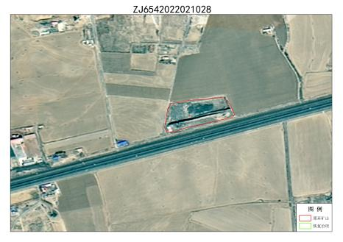
11 | ZJ6542022021027001 | 无法确认治理恢复责任主体的无主废弃矿山 | 乌苏市甘河子镇 | 8219.75 | 84.44968414 | 44.39189911 | 1,84.44888,44.39220  2,84.45035,44.39219  3,84.45055,44.39178  4,84.44930,44.39146 | 